Facies Classification - SVM

# Facies classification using Machine Learning¶

#### Brendon Hall, [Enthought](https://www.enthought.com/)¶

This notebook demonstrates how to train a machine learning algorithm to predict facies from well log data. The dataset we will use comes from a class excercise from The University of Kansas on [Neural Networks and Fuzzy Systems](http://www.people.ku.edu/~gbohling/EECS833/). This exercise is based on a consortium project to use machine learning techniques to create a reservoir model of the largest gas fields in North America, the Hugoton and Panoma Fields. For more info on the origin of the data, see [Bohling and Dubois (2003)](http://www.kgs.ku.edu/PRS/publication/2003/ofr2003-50.pdf) and [Dubois et al. (2007)](http://dx.doi.org/10.1016/j.cageo.2006.08.011).

The dataset we will use is log data from nine wells that have been labeled with a facies type based on oberservation of core. We will use this log data to train a support vector machine to classify facies types. Support vector machines (or SVMs) are a type of supervised learning model that can be trained on data to perform classification and regression tasks. The SVM algorithm uses the training data to fit an optimal hyperplane between the different classes (or facies, in our case). We will use the SVM implementation in [scikit-learn](http://scikit-learn.org/stable/modules/svm.html).

First we will explore the dataset. We will load the training data from 9 wells, and take a look at what we have to work with. We will plot the data from a couple wells, and create cross plots to look at the variation within the data.

Next we will condition the data set. We will remove the entries that have incomplete data. The data will be scaled to have zero mean and unit variance. We will also split the data into training and test sets.

We will then be ready to build the SVM classifier. We will demonstrate how to use the cross validation set to do model parameter selection.

Finally, once we have a built and tuned the classifier, we can apply the trained model to classify facies in wells which do not already have labels. We will apply the classifier to two wells, but in principle you could apply the classifier to any number of wells that had the same log data.

## Exploring the dataset¶

First, we will examine the data set we will use to train the classifier. The training data is contained in the file facies_vectors.csv. The dataset consists of 5 wireline log measurements, two indicator variables and a facies label at half foot intervals. In machine learning terminology, each log measurement is a feature vector that maps a set of 'features' (the log measurements) to a class (the facies type). We will use the pandas library to load the data into a dataframe, which provides a convenient data structure to work with well log data.

In [42]:

%matplotlib inline  
import pandas as pd  
import numpy as np  
import matplotlib as mpl  
import matplotlib.pyplot as plt  
import matplotlib.colors as colors  
from mpl_toolkits.axes_grid1 import make_axes_locatable  
  
from pandas import set_option  
set_option("display.max_rows", 10)  
pd.options.mode.chained_assignment = None  
  
filename = 'facies_vectors.csv'  
training_data = pd.read_csv(filename)  
training_data

Out[42]:

|  | Facies | Formation | Well Name | Depth | GR | ILD_log10 | DeltaPHI | PHIND | PE | NM_M | RELPOS |
| --- | --- | --- | --- | --- | --- | --- | --- | --- | --- | --- | --- |
| 0 | 3 | A1 SH | SHRIMPLIN | 2793.0 | 77.450 | 0.664 | 9.900 | 11.915 | 4.600 | 1 | 1.000 |
| 1 | 3 | A1 SH | SHRIMPLIN | 2793.5 | 78.260 | 0.661 | 14.200 | 12.565 | 4.100 | 1 | 0.979 |
| 2 | 3 | A1 SH | SHRIMPLIN | 2794.0 | 79.050 | 0.658 | 14.800 | 13.050 | 3.600 | 1 | 0.957 |
| 3 | 3 | A1 SH | SHRIMPLIN | 2794.5 | 86.100 | 0.655 | 13.900 | 13.115 | 3.500 | 1 | 0.936 |
| 4 | 3 | A1 SH | SHRIMPLIN | 2795.0 | 74.580 | 0.647 | 13.500 | 13.300 | 3.400 | 1 | 0.915 |
| ... | ... | ... | ... | ... | ... | ... | ... | ... | ... | ... | ... |
| 4144 | 5 | C LM | CHURCHMAN BIBLE | 3120.5 | 46.719 | 0.947 | 1.828 | 7.254 | 3.617 | 2 | 0.685 |
| 4145 | 5 | C LM | CHURCHMAN BIBLE | 3121.0 | 44.563 | 0.953 | 2.241 | 8.013 | 3.344 | 2 | 0.677 |
| 4146 | 5 | C LM | CHURCHMAN BIBLE | 3121.5 | 49.719 | 0.964 | 2.925 | 8.013 | 3.190 | 2 | 0.669 |
| 4147 | 5 | C LM | CHURCHMAN BIBLE | 3122.0 | 51.469 | 0.965 | 3.083 | 7.708 | 3.152 | 2 | 0.661 |
| 4148 | 5 | C LM | CHURCHMAN BIBLE | 3122.5 | 50.031 | 0.970 | 2.609 | 6.668 | 3.295 | 2 | 0.653 |

4149 rows × 11 columns

Remove a single well to use as a blind test later.

In [43]:

blind = training_data[training_data['Well Name'] == 'SHANKLE']  
training_data = training_data[training_data['Well Name'] != 'SHANKLE']

This data is from the Council Grove gas reservoir in Southwest Kansas. The Panoma Council Grove Field is predominantly a carbonate gas reservoir encompassing 2700 square miles in Southwestern Kansas. This dataset is from nine wells (with 4149 examples), consisting of a set of seven predictor variables and a rock facies (class) for each example vector and validation (test) data (830 examples from two wells) having the same seven predictor variables in the feature vector. Facies are based on examination of cores from nine wells taken vertically at half-foot intervals. Predictor variables include five from wireline log measurements and two geologic constraining variables that are derived from geologic knowledge. These are essentially continuous variables sampled at a half-foot sample rate.

The seven predictor variables are:

* Five wire line log curves include [gamma ray](http://petrowiki.org/Gamma_ray_logs) (GR), [resistivity logging](http://petrowiki.org/Resistivity_and_spontaneous_%28SP%29_logging) (ILD_log10),

[photoelectric effect](http://www.glossary.oilfield.slb.com/en/Terms/p/photoelectric_effect.aspx) (PE), [neutron-density porosity difference and average neutron-density porosity](http://petrowiki.org/Neutron_porosity_logs) (DeltaPHI and PHIND). Note, some wells do not have PE.

* Two geologic constraining variables: nonmarine-marine indicator (NM_M) and relative position (RELPOS)

The nine discrete facies (classes of rocks) are:

1. Nonmarine sandstone
2. Nonmarine coarse siltstone
3. Nonmarine fine siltstone
4. Marine siltstone and shale
5. Mudstone (limestone)
6. Wackestone (limestone)
7. Dolomite
8. Packstone-grainstone (limestone)
9. Phylloid-algal bafflestone (limestone)

These facies aren't discrete, and gradually blend into one another. Some have neighboring facies that are rather close. Mislabeling within these neighboring facies can be expected to occur. The following table lists the facies, their abbreviated labels and their approximate neighbors.

| Facies | Label | Adjacent Facies |
| --- | --- | --- |
| 1 | SS | 2 |
| 2 | CSiS | 1,3 |
| 3 | FSiS | 2 |
| 4 | SiSh | 5 |
| 5 | MS | 4,6 |
| 6 | WS | 5,7 |
| 7 | D | 6,8 |
| 8 | PS | 6,7,9 |
| 9 | BS | 7,8 |

Let's clean up this dataset. The 'Well Name' and 'Formation' columns can be turned into a categorical data type.

In [44]:

training_data['Well Name'] = training_data['Well Name'].astype('category')  
training_data['Formation'] = training_data['Formation'].astype('category')  
training_data['Well Name'].unique()

Out[44]:

['SHRIMPLIN', 'ALEXANDER D', 'LUKE G U', 'KIMZEY A', 'CROSS H CATTLE', 'NOLAN', 'Recruit F9', 'NEWBY', 'CHURCHMAN BIBLE']  
Categories (9, object): ['ALEXANDER D', 'CHURCHMAN BIBLE', 'CROSS H CATTLE', 'KIMZEY A', ..., 'NEWBY', 'NOLAN', 'Recruit F9', 'SHRIMPLIN']

These are the names of the 10 training wells in the Council Grove reservoir. Data has been recruited into pseudo-well 'Recruit F9' to better represent facies 9, the Phylloid-algal bafflestone.

Before we plot the well data, let's define a color map so the facies are represented by consistent color in all the plots in this tutorial. We also create the abbreviated facies labels, and add those to the facies_vectors dataframe.

In [ ]:

# 1=sandstone 2=c_siltstone 3=f_siltstone   
# 4=marine_silt_shale 5=mudstone 6=wackestone 7=dolomite  
# 8=packstone 9=bafflestone  
facies_colors = ['#F4D03F', '#F5B041','#DC7633','#6E2C00',  
 '#1B4F72','#2E86C1', '#AED6F1', '#A569BD', '#196F3D']  
  
facies_labels = ['SS', 'CSiS', 'FSiS', 'SiSh', 'MS',  
 'WS', 'D','PS', 'BS']  
#facies_color_map is a dictionary that maps facies labels  
#to their respective colors  
facies_color_map = {}  
for ind, label in enumerate(facies_labels):  
 facies_color_map[label] = facies_colors[ind]  
  
def label_facies(row, labels):  
 return labels[ row['Facies'] -1]  
   
training_data.loc[:,'FaciesLabels'] = training_data.apply(lambda row: label_facies(row, facies_labels), axis=1)  
print(training_data)  
training_data.describe()

Facies Formation Well Name Depth GR ILD_log10 DeltaPHI \  
0 3 A1 SH SHRIMPLIN 2793.0 77.450 0.664 9.900   
1 3 A1 SH SHRIMPLIN 2793.5 78.260 0.661 14.200   
2 3 A1 SH SHRIMPLIN 2794.0 79.050 0.658 14.800   
3 3 A1 SH SHRIMPLIN 2794.5 86.100 0.655 13.900   
4 3 A1 SH SHRIMPLIN 2795.0 74.580 0.647 13.500   
... ... ... ... ... ... ... ...   
4144 5 C LM CHURCHMAN BIBLE 3120.5 46.719 0.947 1.828   
4145 5 C LM CHURCHMAN BIBLE 3121.0 44.563 0.953 2.241   
4146 5 C LM CHURCHMAN BIBLE 3121.5 49.719 0.964 2.925   
4147 5 C LM CHURCHMAN BIBLE 3122.0 51.469 0.965 3.083   
4148 5 C LM CHURCHMAN BIBLE 3122.5 50.031 0.970 2.609   
  
 PHIND PE NM_M RELPOS FaciesLabels   
0 11.915 4.600 1 1.000 FSiS   
1 12.565 4.100 1 0.979 FSiS   
2 13.050 3.600 1 0.957 FSiS   
3 13.115 3.500 1 0.936 FSiS   
4 13.300 3.400 1 0.915 FSiS   
... ... ... ... ... ...   
4144 7.254 3.617 2 0.685 MS   
4145 8.013 3.344 2 0.677 MS   
4146 8.013 3.190 2 0.669 MS   
4147 7.708 3.152 2 0.661 MS   
4148 6.668 3.295 2 0.653 MS   
  
[2783 rows x 12 columns]

Out[ ]:

|  | Facies | Depth | GR | ILD_log10 | DeltaPHI | PHIND | PE | NM_M | RELPOS |
| --- | --- | --- | --- | --- | --- | --- | --- | --- | --- |
| count | 2783.000000 | 2783.000000 | 2783.000000 | 2783.000000 | 2783.000000 | 2783.000000 | 2783.000000 | 2783.000000 | 2783.000000 |
| mean | 4.558390 | 2873.456522 | 66.249445 | 0.644637 | 3.754963 | 13.118929 | 3.805693 | 1.523895 | 0.523057 |
| std | 2.515249 | 138.349383 | 31.610849 | 0.241922 | 5.045916 | 7.389665 | 0.894118 | 0.499518 | 0.287499 |
| min | 1.000000 | 2573.500000 | 13.250000 | -0.025949 | -21.832000 | 0.550000 | 0.200000 | 1.000000 | 0.010000 |
| 25% | 2.000000 | 2767.500000 | 46.081500 | 0.497000 | 1.300000 | 8.165000 | 3.200000 | 1.000000 | 0.276500 |
| 50% | 4.000000 | 2895.000000 | 65.541000 | 0.627000 | 3.581000 | 11.900000 | 3.600000 | 2.000000 | 0.529000 |
| 75% | 7.000000 | 2987.000000 | 80.714000 | 0.812323 | 6.500000 | 16.144000 | 4.400000 | 2.000000 | 0.771500 |
| max | 9.000000 | 3122.500000 | 361.150000 | 1.480000 | 18.500000 | 84.400000 | 8.094000 | 2.000000 | 1.000000 |

This is a quick view of the statistical distribution of the input variables. Looking at the count values, most values have 4149 valid values except for PE, which has 3232. In this tutorial we will drop the feature vectors that don't have a valid PE entry.

In [46]:

PE_mask = training_data['PE'].notnull().values  
training_data = training_data[PE_mask]

Let's take a look at the data from individual wells in a more familiar log plot form. We will create plots for the five well log variables, as well as a log for facies labels. The plots are based on the those described in Alessandro Amato del Monte's [excellent tutorial](https://github.com/seg/tutorials/tree/master/1504_Seismic_petrophysics_1).

In [47]:

def make_facies_log_plot(logs, facies_colors):  
 #make sure logs are sorted by depth  
 logs = logs.sort_values(by='Depth')  
 cmap_facies = colors.ListedColormap(  
 facies_colors[0:len(facies_colors)], 'indexed')  
   
 ztop=logs.Depth.min(); zbot=logs.Depth.max()  
   
 cluster=np.repeat(np.expand_dims(logs['Facies'].values,1), 100, 1)  
   
 f, ax = plt.subplots(nrows=1, ncols=6, figsize=(8, 12))  
 ax[0].plot(logs.GR, logs.Depth, '-g')  
 ax[1].plot(logs.ILD_log10, logs.Depth, '-')  
 ax[2].plot(logs.DeltaPHI, logs.Depth, '-', color='0.5')  
 ax[3].plot(logs.PHIND, logs.Depth, '-', color='r')  
 ax[4].plot(logs.PE, logs.Depth, '-', color='black')  
 im=ax[5].imshow(cluster, interpolation='none', aspect='auto',  
 cmap=cmap_facies,vmin=1,vmax=9)  
   
 divider = make_axes_locatable(ax[5])  
 cax = divider.append_axes("right", size="20%", pad=0.05)  
 cbar=plt.colorbar(im, cax=cax)  
 cbar.set_label((17*' ').join([' SS ', 'CSiS', 'FSiS',   
 'SiSh', ' MS ', ' WS ', ' D ',   
 ' PS ', ' BS ']))  
 cbar.set_ticks(range(0,1)); cbar.set_ticklabels('')  
   
 for i in range(len(ax)-1):  
 ax[i].set_ylim(ztop,zbot)  
 ax[i].invert_yaxis()  
 ax[i].grid()  
 ax[i].locator_params(axis='x', nbins=3)  
   
 ax[0].set_xlabel("GR")  
 ax[0].set_xlim(logs.GR.min(),logs.GR.max())  
 ax[1].set_xlabel("ILD_log10")  
 ax[1].set_xlim(logs.ILD_log10.min(),logs.ILD_log10.max())  
 ax[2].set_xlabel("DeltaPHI")  
 ax[2].set_xlim(logs.DeltaPHI.min(),logs.DeltaPHI.max())  
 ax[3].set_xlabel("PHIND")  
 ax[3].set_xlim(logs.PHIND.min(),logs.PHIND.max())  
 ax[4].set_xlabel("PE")  
 ax[4].set_xlim(logs.PE.min(),logs.PE.max())  
 ax[5].set_xlabel('Facies')  
   
 ax[1].set_yticklabels([]); ax[2].set_yticklabels([]); ax[3].set_yticklabels([])  
 ax[4].set_yticklabels([]); ax[5].set_yticklabels([])  
 ax[5].set_xticklabels([])  
 f.suptitle('Well: %s'%logs.iloc[0]['Well Name'], fontsize=14,y=0.94)

Placing the log plotting code in a function will make it easy to plot the logs from multiples wells, and can be reused later to view the results when we apply the facies classification model to other wells. The function was written to take a list of colors and facies labels as parameters.

We then show log plots for wells SHRIMPLIN.

In [48]:

make_facies_log_plot(  
 training_data[training_data['Well Name'] == 'SHRIMPLIN'],  
 facies_colors)

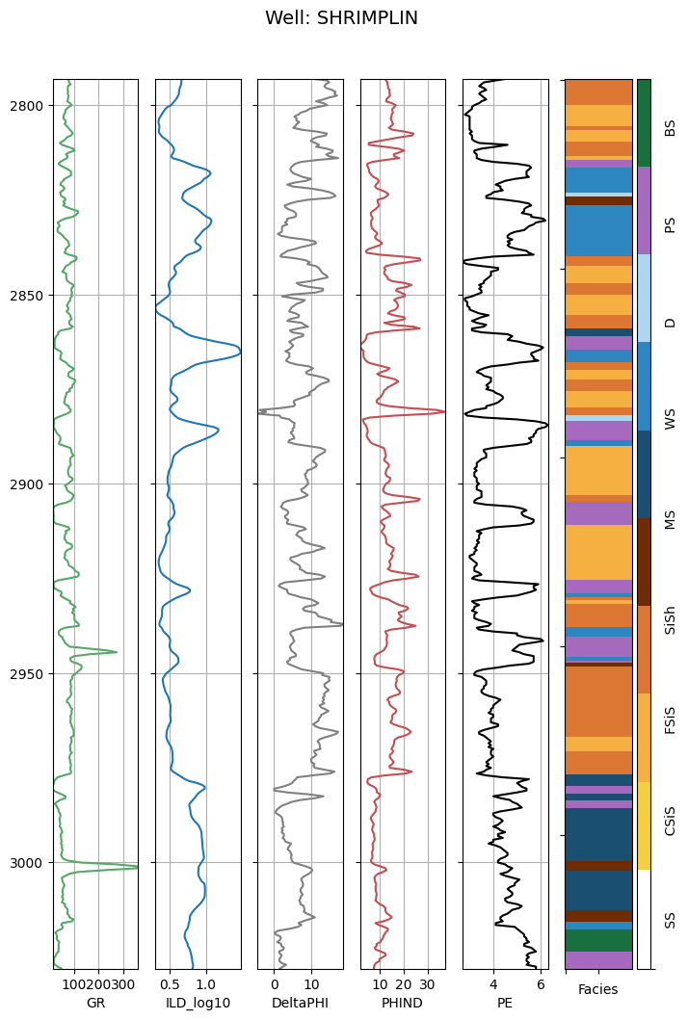

In addition to individual wells, we can look at how the various facies are represented by the entire training set. Let's plot a histogram of the number of training examples for each facies class.

In [49]:

#count the number of unique entries for each facies, sort them by  
#facies number (instead of by number of entries)  
facies_counts = training_data['Facies'].value_counts().sort_index()  
#use facies labels to index each count  
facies_counts.index = facies_labels  
  
facies_counts.plot(kind='bar',color=facies_colors,   
 title='Distribution of Training Data by Facies')  
print(facies_counts)

SS 170  
CSiS 649  
FSiS 498  
SiSh 177  
MS 198  
WS 391  
D 81  
PS 458  
BS 161  
Name: count, dtype: int64

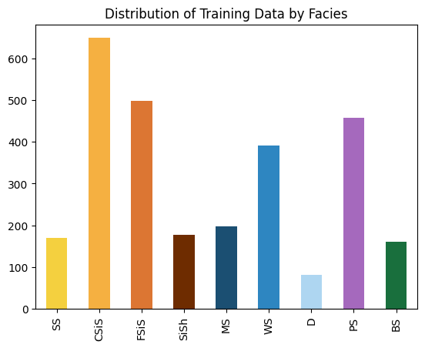

This shows the distribution of examples by facies for the 3232 training examples in the training set. Dolomite (facies 7) has the fewest with 141 examples. There are also only 185 bafflestone examples. Depending on the performance of the classifier we are going to train, we may consider getting more examples of these facies.

Crossplots are a familiar tool in the geosciences to visualize how two properties vary with rock type. This dataset contains 5 log variables, and scatter matrix can help to quickly visualize the variation between the all the variables in the dataset. We can employ the very useful [Seaborn library](https://stanford.edu/~mwaskom/software/seaborn/) to quickly create a nice looking scatter matrix. Each pane in the plot shows the relationship between two of the variables on the x and y axis, with each point is colored according to its facies. The same colormap is used to represent the 9 facies.

In [50]:

#save plot display settings to change back to when done plotting with seaborn  
inline_rc = dict(mpl.rcParams)  
  
import seaborn as sns  
sns.set()  
sns.pairplot(training_data.drop(['Well Name','Facies','Formation','Depth','NM_M','RELPOS'],axis=1),  
 hue='FaciesLabels', palette=facies_color_map,  
 hue_order=list(reversed(facies_labels)))  
  
#switch back to default matplotlib plot style  
mpl.rcParams.update(inline_rc)

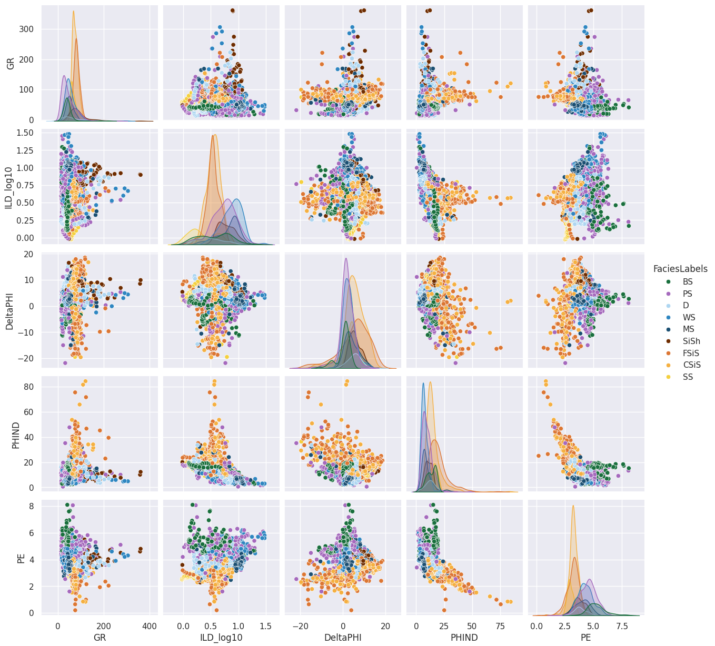

In [ ]:

## Conditioning the data set¶

Now we extract just the feature variables we need to perform the classification. The predictor variables are the five wireline values and two geologic constraining variables. We also get a vector of the facies labels that correspond to each feature vector.

In [51]:

correct_facies_labels = training_data['Facies'].values  
  
feature_vectors = training_data.drop(['Formation', 'Well Name', 'Depth','Facies','FaciesLabels'], axis=1)  
feature_vectors.describe()

Out[51]:

|  | GR | ILD_log10 | DeltaPHI | PHIND | PE | NM_M | RELPOS |
| --- | --- | --- | --- | --- | --- | --- | --- |
| count | 2783.000000 | 2783.000000 | 2783.000000 | 2783.000000 | 2783.000000 | 2783.000000 | 2783.000000 |
| mean | 66.249445 | 0.644637 | 3.754963 | 13.118929 | 3.805693 | 1.523895 | 0.523057 |
| std | 31.610849 | 0.241922 | 5.045916 | 7.389665 | 0.894118 | 0.499518 | 0.287499 |
| min | 13.250000 | -0.025949 | -21.832000 | 0.550000 | 0.200000 | 1.000000 | 0.010000 |
| 25% | 46.081500 | 0.497000 | 1.300000 | 8.165000 | 3.200000 | 1.000000 | 0.276500 |
| 50% | 65.541000 | 0.627000 | 3.581000 | 11.900000 | 3.600000 | 2.000000 | 0.529000 |
| 75% | 80.714000 | 0.812323 | 6.500000 | 16.144000 | 4.400000 | 2.000000 | 0.771500 |
| max | 361.150000 | 1.480000 | 18.500000 | 84.400000 | 8.094000 | 2.000000 | 1.000000 |

Scikit includes a [preprocessing](http://scikit-learn.org/stable/modules/preprocessing.html) module that can 'standardize' the data (giving each variable zero mean and unit variance, also called *whitening*). Many machine learning algorithms assume features will be standard normally distributed data (ie: Gaussian with zero mean and unit variance). The factors used to standardize the training set must be applied to any subsequent feature set that will be input to the classifier. The StandardScalar class can be fit to the training set, and later used to standardize any training data.

In [52]:

from sklearn import preprocessing  
  
scaler = preprocessing.StandardScaler().fit(feature_vectors)  
scaled_features = scaler.transform(feature_vectors)

In [53]:

feature_vectors

Out[53]:

|  | GR | ILD_log10 | DeltaPHI | PHIND | PE | NM_M | RELPOS |
| --- | --- | --- | --- | --- | --- | --- | --- |
| 0 | 77.450 | 0.664 | 9.900 | 11.915 | 4.600 | 1 | 1.000 |
| 1 | 78.260 | 0.661 | 14.200 | 12.565 | 4.100 | 1 | 0.979 |
| 2 | 79.050 | 0.658 | 14.800 | 13.050 | 3.600 | 1 | 0.957 |
| 3 | 86.100 | 0.655 | 13.900 | 13.115 | 3.500 | 1 | 0.936 |
| 4 | 74.580 | 0.647 | 13.500 | 13.300 | 3.400 | 1 | 0.915 |
| ... | ... | ... | ... | ... | ... | ... | ... |
| 4144 | 46.719 | 0.947 | 1.828 | 7.254 | 3.617 | 2 | 0.685 |
| 4145 | 44.563 | 0.953 | 2.241 | 8.013 | 3.344 | 2 | 0.677 |
| 4146 | 49.719 | 0.964 | 2.925 | 8.013 | 3.190 | 2 | 0.669 |
| 4147 | 51.469 | 0.965 | 3.083 | 7.708 | 3.152 | 2 | 0.661 |
| 4148 | 50.031 | 0.970 | 2.609 | 6.668 | 3.295 | 2 | 0.653 |

2783 rows × 7 columns

In [54]:

pscale = pd.DataFrame(scaled_features)  
sns.pairplot(pscale.drop([5, 6], axis=1))

Out[54]:

<seaborn.axisgrid.PairGrid at 0x140c04510>

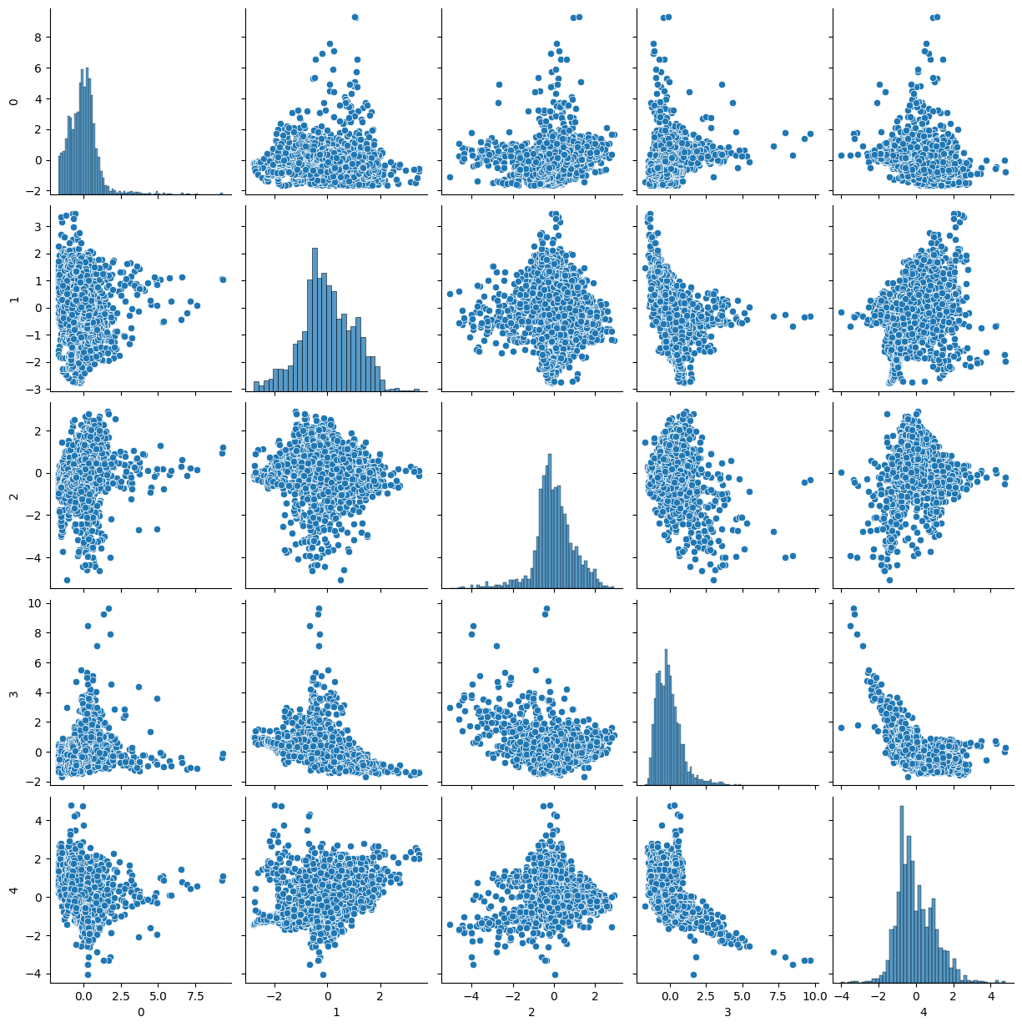

Scikit also includes a handy function to randomly split the training data into training and test sets. The test set contains a small subset of feature vectors that are not used to train the network. Because we know the true facies labels for these examples, we can compare the results of the classifier to the actual facies and determine the accuracy of the model. Let's use 20% of the data for the test set.

In [55]:

# from sklearn.cross_validation import train_test_split  
from sklearn.model_selection import train_test_split  
# Split the data into training and testing sets  
X_train, X_test, y_train, y_test = train_test_split(  
 scaled_features, correct_facies_labels, test_size=0.2, random_state=42)

## Training the SVM classifier¶

Now we use the cleaned and conditioned training set to create a facies classifier. As mentioned above, we will use a type of machine learning model known as a [support vector machine](https://en.wikipedia.org/wiki/Support_vector_machine). The SVM is a map of the feature vectors as points in a multi dimensional space, mapped so that examples from different facies are divided by a clear gap that is as wide as possible.

The SVM implementation in [scikit-learn](http://scikit-learn.org/stable/modules/generated/sklearn.svm.SVC.html#sklearn.svm.SVC) takes a number of important parameters. First we create a classifier using the default settings.

In [56]:

from sklearn import svm  
  
clf = svm.SVC()

Now we can train the classifier using the training set we created above.

In [57]:

clf.fit(X_train,y_train)

Out[57]:

SVC()

**In a Jupyter environment, please rerun this cell to show the HTML representation or trust the notebook.**  
**On GitHub, the HTML representation is unable to render, please try loading this page with nbviewer.org.**

SVC

[?Documentation for SVC](https://scikit-learn.org/1.6/modules/generated/sklearn.svm.SVC.html)iFitted

SVC()

Now that the model has been trained on our data, we can use it to predict the facies of the feature vectors in the test set. Because we know the true facies labels of the vectors in the test set, we can use the results to evaluate the accuracy of the classifier.

In [58]:

predicted_labels = clf.predict(X_test)

We need some metrics to evaluate how good our classifier is doing. A [confusion matrix](http://www.dataschool.io/simple-guide-to-confusion-matrix-terminology/) is a table that can be used to describe the performance of a classification model. [Scikit-learn](http://scikit-learn.org/stable/modules/generated/sklearn.metrics.confusion_matrix.html) allows us to easily create a confusion matrix by supplying the actual and predicted facies labels.

The confusion matrix is simply a 2D array. The entries of confusion matrix C[i][j] are equal to the number of observations predicted to have facies j, but are known to have facies i.

To simplify reading the confusion matrix, a function has been written to display the matrix along with facies labels and various error metrics. See the file classification_utilities.py in this repo for the display_cm() function.

In [59]:

from sklearn.metrics import confusion_matrix  
from classification_utilities import display_cm, display_adj_cm  
  
conf = confusion_matrix(y_test, predicted_labels)  
display_cm(conf, facies_labels, hide_zeros=True)  
sns.heatmap(conf, annot=True, fmt='d', cmap='Blues',  
 xticklabels=facies_labels, yticklabels=facies_labels)

Pred SS CSiS FSiS SiSh MS WS D PS BS Total  
 True  
 SS 19 19 1 39  
 CSiS 102 28 130  
 FSiS 33 49 1 1 84  
 SiSh 1 24 6 2 33  
 MS 2 1 2 2 42 1 10 60  
 WS 7 43 2 19 1 72  
 D 1 9 7 17  
 PS 2 1 2 22 56 5 88  
 BS 1 11 22 34

Out[59]:

<Axes: >

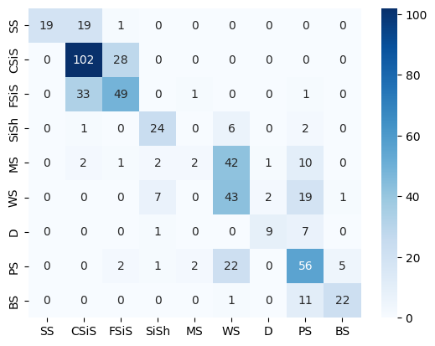

The rows of the confusion matrix correspond to the actual facies labels. The columns correspond to the labels assigned by the classifier. For example, consider the first row. For the feature vectors in the test set that actually have label SS, 23 were correctly indentified as SS, 21 were classified as CSiS and 2 were classified as FSiS.

The entries along the diagonal are the facies that have been correctly classified. Below we define two functions that will give an overall value for how the algorithm is performing. The accuracy is defined as the number of correct classifications divided by the total number of classifications.

In [60]:

def accuracy(conf):  
 total_correct = 0.  
 nb_classes = conf.shape[0]  
 for i in np.arange(0,nb_classes):  
 total_correct += conf[i][i]  
 acc = total_correct/sum(sum(conf))  
 return acc

As noted above, the boundaries between the facies classes are not all sharp, and some of them blend into one another. The error within these 'adjacent facies' can also be calculated. We define an array to represent the facies adjacent to each other. For facies label i, adjacent_facies[i] is an array of the adjacent facies labels.

In [61]:

adjacent_facies = np.array([[1], [0,2], [1], [4], [3,5], [4,6,7], [5,7], [5,6,8], [6,7]], dtype=object)  
  
def accuracy_adjacent(conf, adjacent_facies):  
 nb_classes = conf.shape[0]  
 total_correct = 0.  
 for i in np.arange(0,nb_classes):  
 total_correct += conf[i][i]  
 for j in adjacent_facies[i]:  
 total_correct += conf[i][j]  
 return total_correct / sum(sum(conf))

In [62]:

print('Facies classification accuracy = %f' % accuracy(conf))  
print('Adjacent facies classification accuracy = %f' % accuracy_adjacent(conf, adjacent_facies))

Facies classification accuracy = 0.585278  
Adjacent facies classification accuracy = 0.926391

## Model parameter selection¶

The classifier so far has been built with the default parameters. However, we may be able to get improved classification results with optimal parameter choices.

We will consider two parameters. The parameter C is a regularization factor, and tells the classifier how much we want to avoid misclassifying training examples. A large value of C will try to correctly classify more examples from the training set, but if C is too large it may 'overfit' the data and fail to generalize when classifying new data. If C is too small then the model will not be good at fitting outliers and will have a large error on the training set.

The SVM learning algorithm uses a kernel function to compute the distance between feature vectors. Many kernel functions exist, but in this case we are using the radial basis function rbf kernel (the default). The gamma parameter describes the size of the radial basis functions, which is how far away two vectors in the feature space need to be to be considered close.

We will train a series of classifiers with different values for C and gamma. Two nested loops are used to train a classifier for every possible combination of values in the ranges specified. The classification accuracy is recorded for each combination of parameter values. The results are shown in a series of plots, so the parameter values that give the best classification accuracy on the test set can be selected.

This process is also known as 'cross validation'. Often a separate 'cross validation' dataset will be created in addition to the training and test sets to do model selection. For this tutorial we will just use the test set to choose model parameters.

In [63]:

#model selection takes a few minutes, change this variable  
#to true to run the parameter loop  
do_model_selection = True  
  
if do_model_selection:  
 C_range = np.array([.01, 1, 5, 10, 20, 50, 100, 1000, 5000, 10000])  
 gamma_range = np.array([0.0001, 0.001, 0.01, 0.1, 1, 10])  
   
 fig, axes = plt.subplots(3, 2,   
 sharex='col', sharey='row',figsize=(10,10))  
 plot_number = 0  
 for outer_ind, gamma_value in enumerate(gamma_range):  
 row = int(plot_number / 2)  
 column = int(plot_number % 2)  
 cv_errors = np.zeros(C_range.shape)  
 train_errors = np.zeros(C_range.shape)  
 for index, c_value in enumerate(C_range):  
   
 clf = svm.SVC(C=c_value, gamma=gamma_value)  
 clf.fit(X_train,y_train)  
   
 train_conf = confusion_matrix(y_train, clf.predict(X_train))  
 cv_conf = confusion_matrix(y_test, clf.predict(X_test))  
   
 cv_errors[index] = accuracy(cv_conf)  
 train_errors[index] = accuracy(train_conf)  
  
 ax = axes[row, column]  
 ax.set_title('Gamma = %g'%gamma_value)  
 ax.semilogx(C_range, cv_errors, label='CV error')  
 ax.semilogx(C_range, train_errors, label='Train error')  
 plot_number += 1  
 ax.set_ylim([0.2,1])  
   
 ax.legend(bbox_to_anchor=(1.05, 0), loc='lower left', borderaxespad=0.)  
 fig.text(0.5, 0.03, 'C value', ha='center',  
 fontsize=14)  
   
 fig.text(0.04, 0.5, 'Classification Accuracy', va='center',   
 rotation='vertical', fontsize=14)

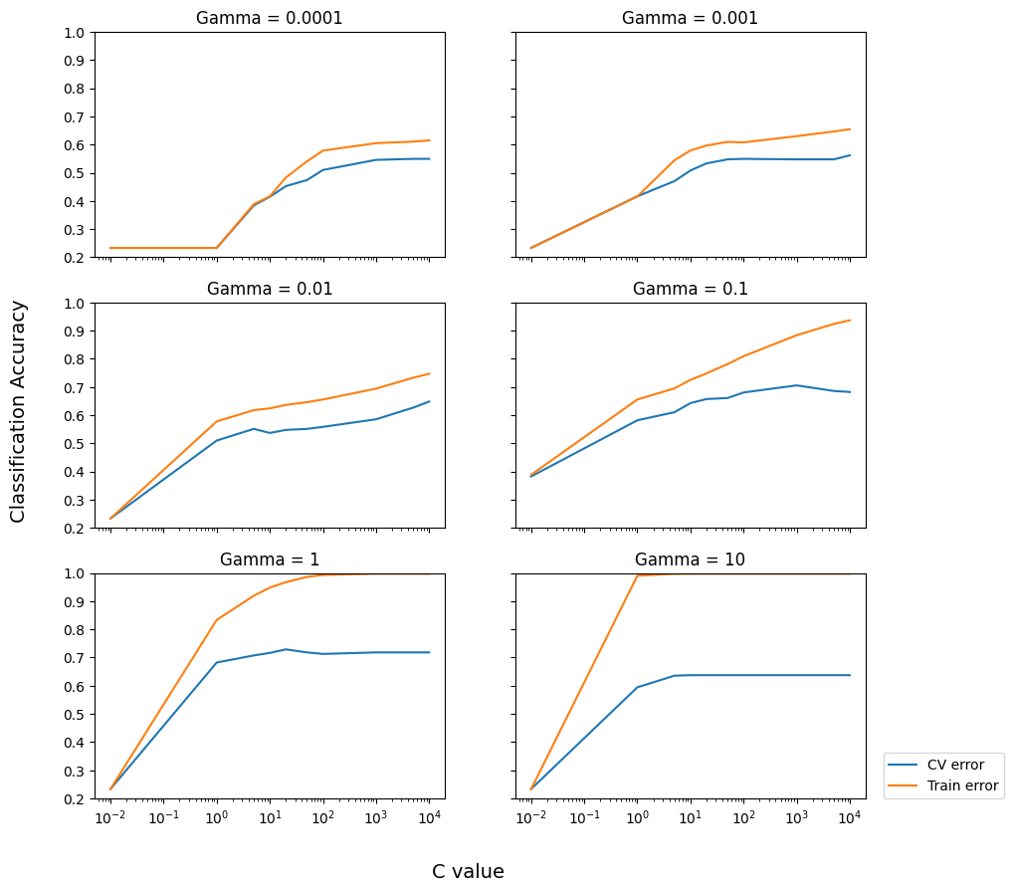

The best accuracy on the cross validation error curve was achieved for gamma = 1, and C = 10. We can now create and train an optimized classifier based on these parameters:

In [64]:

clf = svm.SVC(C=10, gamma=1)   
clf.fit(X_train, y_train)  
  
cv_conf = confusion_matrix(y_test, clf.predict(X_test))  
  
print('Optimized facies classification accuracy = %.2f' % accuracy(cv_conf))  
print('Optimized adjacent facies classification accuracy = %.2f' % accuracy_adjacent(cv_conf, adjacent_facies))

Optimized facies classification accuracy = 0.72  
Optimized adjacent facies classification accuracy = 0.92

[Precision and recall](https://en.wikipedia.org/wiki/Precision_and_recall) are metrics that give more insight into how the classifier performs for individual facies. Precision is the probability that given a classification result for a sample, the sample actually belongs to that class. Recall is the probability that a sample will be correctly classified for a given class.

Precision and recall can be computed easily using the confusion matrix. The code to do so has been added to the display_confusion_matrix() function:

In [65]:

display_cm(cv_conf, facies_labels,   
 display_metrics=True, hide_zeros=True)  
  
sns.heatmap(cv_conf, annot=True, fmt='d', cmap='Blues',  
 xticklabels=facies_labels, yticklabels=facies_labels)

Pred SS CSiS FSiS SiSh MS WS D PS BS Total  
 True  
 SS 30 8 1 39  
 CSiS 2 109 17 2 130  
 FSiS 2 23 55 3 1 84  
 SiSh 1 27 1 2 2 33  
 MS 2 2 5 29 14 8 60  
 WS 7 8 45 1 9 2 72  
 D 1 2 10 3 1 17  
 PS 3 1 3 14 63 4 88  
 BS 3 31 34  
  
Precision 0.88 0.76 0.71 0.61 0.66 0.60 0.91 0.70 0.82 0.72  
 Recall 0.77 0.84 0.65 0.82 0.48 0.62 0.59 0.72 0.91 0.72  
 F1 0.82 0.80 0.68 0.70 0.56 0.61 0.71 0.71 0.86 0.71

Out[65]:

<Axes: >

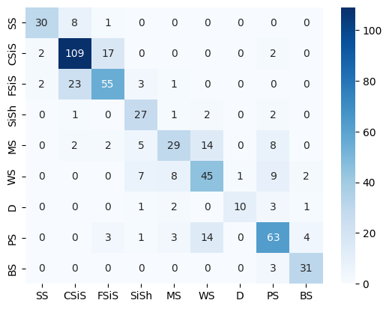

To interpret these results, consider facies SS. In our test set, if a sample was labeled SS the probability the sample was correct is 0.8 (precision). If we know a sample has facies SS, then the probability it will be correctly labeled by the classifier is 0.78 (recall). It is desirable to have high values for both precision and recall, but often when an algorithm is tuned to increase one, the other decreases. The [F1 score](https://en.wikipedia.org/wiki/Precision_and_recall#F-measure) combines both to give a single measure of relevancy of the classifier results.

These results can help guide intuition for how to improve the classifier results. For example, for a sample with facies MS or mudstone, it is only classified correctly 57% of the time (recall). Perhaps this could be improved by introducing more training samples. Sample quality could also play a role. Facies BS or bafflestone has the best F1 score and relatively few training examples. But this data was handpicked from other wells to provide training examples to identify this facies.

We can also consider the classification metrics when we consider misclassifying an adjacent facies as correct:

In [66]:

display_adj_cm(cv_conf, facies_labels, adjacent_facies,   
 display_metrics=True, hide_zeros=True)

Pred SS CSiS FSiS SiSh MS WS D PS BS Total  
 True  
 SS 38 1 39  
 CSiS 128 2 130  
 FSiS 2 78 3 1 84  
 SiSh 1 28 2 2 33  
 MS 2 2 48 8 60  
 WS 7 63 2 72  
 D 1 2 13 1 17  
 PS 3 1 3 81 88  
 BS 34 34  
  
Precision 0.95 0.98 0.93 0.70 0.89 0.97 1.00 0.87 0.92 0.92  
 Recall 0.97 0.98 0.93 0.85 0.80 0.88 0.76 0.92 1.00 0.92  
 F1 0.96 0.98 0.93 0.77 0.84 0.92 0.87 0.90 0.96 0.92

Considering adjacent facies, the F1 scores for all facies types are above 0.9, except when classifying SiSh or marine siltstone and shale. The classifier often misclassifies this facies (recall of 0.66), most often as wackestone.

These results are comparable to those reported in Dubois et al. (2007).

## Applying the classification model to the blind data¶

We held a well back from the training, and stored it in a dataframe called blind:

In [67]:

blind

Out[67]:

|  | Facies | Formation | Well Name | Depth | GR | ILD_log10 | DeltaPHI | PHIND | PE | NM_M | RELPOS |
| --- | --- | --- | --- | --- | --- | --- | --- | --- | --- | --- | --- |
| 937 | 2 | A1 SH | SHANKLE | 2774.5 | 98.36 | 0.642 | -0.1 | 18.685 | 2.9 | 1 | 1.000 |
| 938 | 2 | A1 SH | SHANKLE | 2775.0 | 97.57 | 0.631 | 7.9 | 16.745 | 3.2 | 1 | 0.984 |
| 939 | 2 | A1 SH | SHANKLE | 2775.5 | 98.41 | 0.615 | 12.8 | 14.105 | 3.2 | 1 | 0.968 |
| 940 | 2 | A1 SH | SHANKLE | 2776.0 | 85.92 | 0.597 | 13.0 | 13.385 | 3.4 | 1 | 0.952 |
| 941 | 2 | A1 SH | SHANKLE | 2776.5 | 83.16 | 0.592 | 12.3 | 13.345 | 3.4 | 1 | 0.935 |
| ... | ... | ... | ... | ... | ... | ... | ... | ... | ... | ... | ... |
| 1381 | 8 | C LM | SHANKLE | 3006.0 | 32.84 | 1.120 | -2.2 | 3.455 | 5.1 | 2 | 0.060 |
| 1382 | 8 | C LM | SHANKLE | 3006.5 | 25.16 | 1.112 | -1.6 | 2.890 | 4.8 | 2 | 0.045 |
| 1383 | 8 | C LM | SHANKLE | 3007.0 | 25.16 | 1.112 | -1.6 | 2.890 | 4.8 | 2 | 0.030 |
| 1384 | 4 | C LM | SHANKLE | 3007.5 | 26.22 | 1.092 | -0.4 | 3.400 | 4.5 | 2 | 0.030 |
| 1385 | 4 | C LM | SHANKLE | 3008.0 | 65.36 | 1.026 | 1.6 | 4.715 | 4.5 | 2 | 0.015 |

449 rows × 11 columns

The label vector is just the Facies column:

In [68]:

y_blind = blind['Facies'].values

We can form the feature matrix by dropping some of the columns and making a new dataframe:

In [69]:

well_features = blind.drop(['Facies', 'Formation', 'Well Name', 'Depth'], axis=1)

Now we can transform this with the scaler we made before:

In [70]:

X_blind = scaler.transform(well_features)

Now it's a simple matter of making a prediction and storing it back in the dataframe:

In [71]:

y_pred = clf.predict(X_blind)  
blind['Prediction'] = y_pred

Let's see how we did with the confusion matrix:

In [72]:

cv_conf = confusion_matrix(y_blind, y_pred)  
  
print('Optimized facies classification accuracy = %.2f' % accuracy(cv_conf))  
print('Optimized adjacent facies classification accuracy = %.2f' % accuracy_adjacent(cv_conf, adjacent_facies))

Optimized facies classification accuracy = 0.42  
Optimized adjacent facies classification accuracy = 0.87

We managed 0.75 using the test data, but it was from the same wells as the training data. This more reasonable test does not perform as well...

In [73]:

display_cm(cv_conf, facies_labels,  
 display_metrics=True, hide_zeros=True)

Pred SS CSiS FSiS SiSh MS WS D PS BS Total  
 True  
 SS 6 60 23 89  
 CSiS 14 61 14 89  
 FSiS 2 51 63 1 117  
 SiSh 1 5 1 7  
 MS 3 1 4 9 2 19  
 WS 3 3 20 29 16 71  
 D 4 1 3 2 7 17  
 PS 1 12 2 24 1 40  
 BS 0  
  
Precision 0.27 0.35 0.59 0.12 0.04 0.58 0.50 0.41 0.00 0.43  
 Recall 0.07 0.69 0.54 0.14 0.05 0.41 0.12 0.60 0.00 0.42  
 F1 0.11 0.47 0.56 0.13 0.05 0.48 0.19 0.49 0.00 0.39

/Users/songkhunboonchaisuk/Downloads/_Projects/ML/tutorials-2016-master/1610_Facies_classification/classification_utilities.py:12: RuntimeWarning: invalid value encountered in divide  
 recall = np.diagonal(cm)/cm.sum(axis=1).astype('float')

...but does remarkably well on the adjacent facies predictions.

In [74]:

display_adj_cm(cv_conf, facies_labels, adjacent_facies,  
 display_metrics=True, hide_zeros=True)

Pred SS CSiS FSiS SiSh MS WS D PS BS Total  
 True  
 SS 66 23 89  
 CSiS 89 89  
 FSiS 2 114 1 117  
 SiSh 1 5 1 7  
 MS 8 9 2 19  
 WS 3 3 65 71  
 D 4 1 3 9 17  
 PS 1 39 40  
 BS 0  
  
Precision 0.97 1.00 0.79 0.20 0.67 0.93 1.00 0.78 0.00 0.88  
 Recall 0.74 1.00 0.97 0.14 0.42 0.92 0.53 0.97 0.00 0.87  
 F1 0.84 1.00 0.87 0.17 0.52 0.92 0.69 0.87 0.00 0.87

In [75]:

def compare_facies_plot(logs, compadre, facies_colors):  
 #make sure logs are sorted by depth  
 logs = logs.sort_values(by='Depth')  
 cmap_facies = colors.ListedColormap(  
 facies_colors[0:len(facies_colors)], 'indexed')  
   
 ztop=logs.Depth.min(); zbot=logs.Depth.max()  
   
 cluster1 = np.repeat(np.expand_dims(logs['Facies'].values,1), 100, 1)  
 cluster2 = np.repeat(np.expand_dims(logs[compadre].values,1), 100, 1)  
   
 f, ax = plt.subplots(nrows=1, ncols=7, figsize=(9, 12))  
 ax[0].plot(logs.GR, logs.Depth, '-g')  
 ax[1].plot(logs.ILD_log10, logs.Depth, '-')  
 ax[2].plot(logs.DeltaPHI, logs.Depth, '-', color='0.5')  
 ax[3].plot(logs.PHIND, logs.Depth, '-', color='r')  
 ax[4].plot(logs.PE, logs.Depth, '-', color='black')  
 im1 = ax[5].imshow(cluster1, interpolation='none', aspect='auto',  
 cmap=cmap_facies,vmin=1,vmax=9)  
 im2 = ax[6].imshow(cluster2, interpolation='none', aspect='auto',  
 cmap=cmap_facies,vmin=1,vmax=9)  
   
 divider = make_axes_locatable(ax[6])  
 cax = divider.append_axes("right", size="20%", pad=0.05)  
 cbar=plt.colorbar(im2, cax=cax)  
 cbar.set_label((17*' ').join([' SS ', 'CSiS', 'FSiS',   
 'SiSh', ' MS ', ' WS ', ' D ',   
 ' PS ', ' BS ']))  
 cbar.set_ticks(range(0,1)); cbar.set_ticklabels('')  
   
 for i in range(len(ax)-2):  
 ax[i].set_ylim(ztop,zbot)  
 ax[i].invert_yaxis()  
 ax[i].grid()  
 ax[i].locator_params(axis='x', nbins=3)  
   
 ax[0].set_xlabel("GR")  
 ax[0].set_xlim(logs.GR.min(),logs.GR.max())  
 ax[1].set_xlabel("ILD_log10")  
 ax[1].set_xlim(logs.ILD_log10.min(),logs.ILD_log10.max())  
 ax[2].set_xlabel("DeltaPHI")  
 ax[2].set_xlim(logs.DeltaPHI.min(),logs.DeltaPHI.max())  
 ax[3].set_xlabel("PHIND")  
 ax[3].set_xlim(logs.PHIND.min(),logs.PHIND.max())  
 ax[4].set_xlabel("PE")  
 ax[4].set_xlim(logs.PE.min(),logs.PE.max())  
 ax[5].set_xlabel('Facies')  
 ax[6].set_xlabel(compadre)  
   
 ax[1].set_yticklabels([]); ax[2].set_yticklabels([]); ax[3].set_yticklabels([])  
 ax[4].set_yticklabels([]); ax[5].set_yticklabels([])  
 ax[5].set_xticklabels([])  
 ax[6].set_xticklabels([])  
 f.suptitle('Well: %s'%logs.iloc[0]['Well Name'], fontsize=14,y=0.94)

In [76]:

compare_facies_plot(blind, 'Prediction', facies_colors)

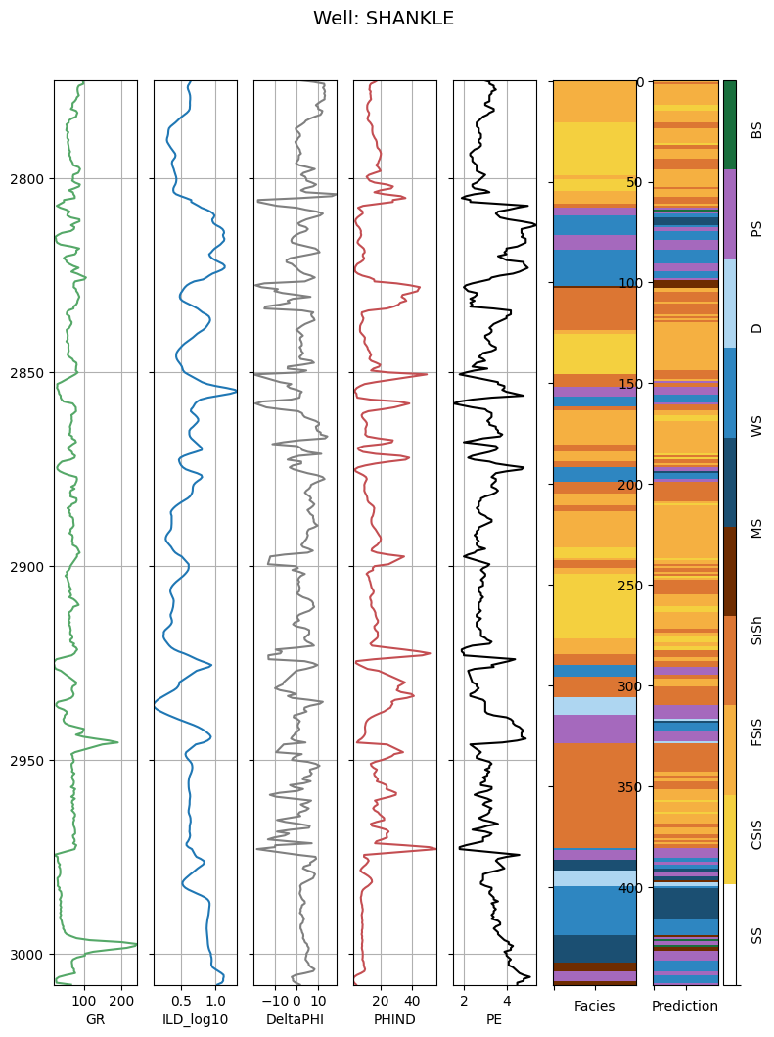

## Applying the classification model to new data¶

Now that we have a trained facies classification model we can use it to identify facies in wells that do not have core data. In this case, we will apply the classifier to two wells, but we could use it on any number of wells for which we have the same set of well logs for input.

This dataset is similar to the training data except it does not have facies labels. It is loaded into a dataframe called test_data.

In [77]:

well_data = pd.read_csv('validation_data_nofacies.csv')  
well_data['Well Name'] = well_data['Well Name'].astype('category')  
well_features = well_data.drop(['Formation', 'Well Name', 'Depth'], axis=1)

The data needs to be scaled using the same constants we used for the training data.

In [78]:

X_unknown = scaler.transform(well_features)

Finally we predict facies labels for the unknown data, and store the results in a Facies column of the test_data dataframe.

In [79]:

#predict facies of unclassified data  
y_unknown = clf.predict(X_unknown)  
well_data['Facies'] = y_unknown  
well_data

Out[79]:

|  | Formation | Well Name | Depth | GR | ILD_log10 | DeltaPHI | PHIND | PE | NM_M | RELPOS | Facies |
| --- | --- | --- | --- | --- | --- | --- | --- | --- | --- | --- | --- |
| 0 | A1 SH | STUART | 2808.0 | 66.276 | 0.630 | 3.300 | 10.650 | 3.591 | 1 | 1.000 | 3 |
| 1 | A1 SH | STUART | 2808.5 | 77.252 | 0.585 | 6.500 | 11.950 | 3.341 | 1 | 0.978 | 3 |
| 2 | A1 SH | STUART | 2809.0 | 82.899 | 0.566 | 9.400 | 13.600 | 3.064 | 1 | 0.956 | 3 |
| 3 | A1 SH | STUART | 2809.5 | 80.671 | 0.593 | 9.500 | 13.250 | 2.977 | 1 | 0.933 | 3 |
| 4 | A1 SH | STUART | 2810.0 | 75.971 | 0.638 | 8.700 | 12.350 | 3.020 | 1 | 0.911 | 1 |
| ... | ... | ... | ... | ... | ... | ... | ... | ... | ... | ... | ... |
| 825 | C SH | CRAWFORD | 3158.5 | 86.078 | 0.554 | 5.040 | 16.150 | 3.161 | 1 | 0.639 | 3 |
| 826 | C SH | CRAWFORD | 3159.0 | 88.855 | 0.539 | 5.560 | 16.750 | 3.118 | 1 | 0.611 | 3 |
| 827 | C SH | CRAWFORD | 3159.5 | 90.490 | 0.530 | 6.360 | 16.780 | 3.168 | 1 | 0.583 | 3 |
| 828 | C SH | CRAWFORD | 3160.0 | 90.975 | 0.522 | 7.035 | 16.995 | 3.154 | 1 | 0.556 | 3 |
| 829 | C SH | CRAWFORD | 3160.5 | 90.108 | 0.513 | 7.505 | 17.595 | 3.125 | 1 | 0.528 | 3 |

830 rows × 11 columns

In [80]:

well_data['Well Name'].unique()

Out[80]:

['STUART', 'CRAWFORD']  
Categories (2, object): ['CRAWFORD', 'STUART']

We can use the well log plot to view the classification results along with the well logs.

In [81]:

make_facies_log_plot(  
 well_data[well_data['Well Name'] == 'STUART'],  
 facies_colors=facies_colors)  
  
make_facies_log_plot(  
 well_data[well_data['Well Name'] == 'CRAWFORD'],  
 facies_colors=facies_colors)

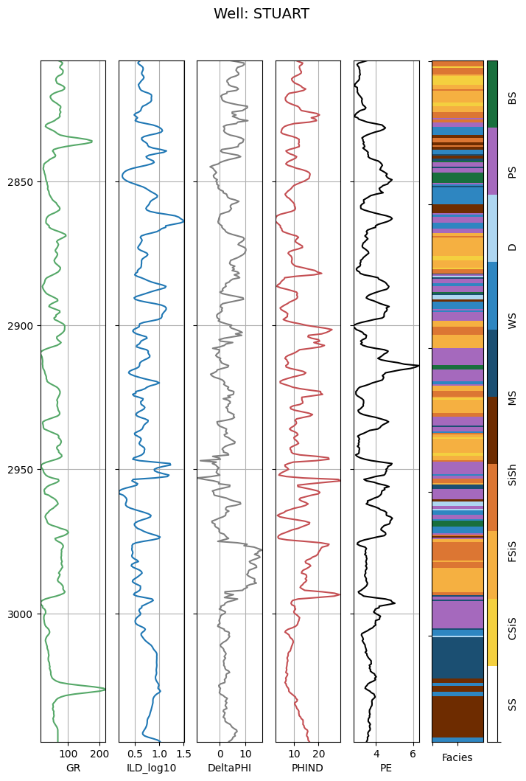

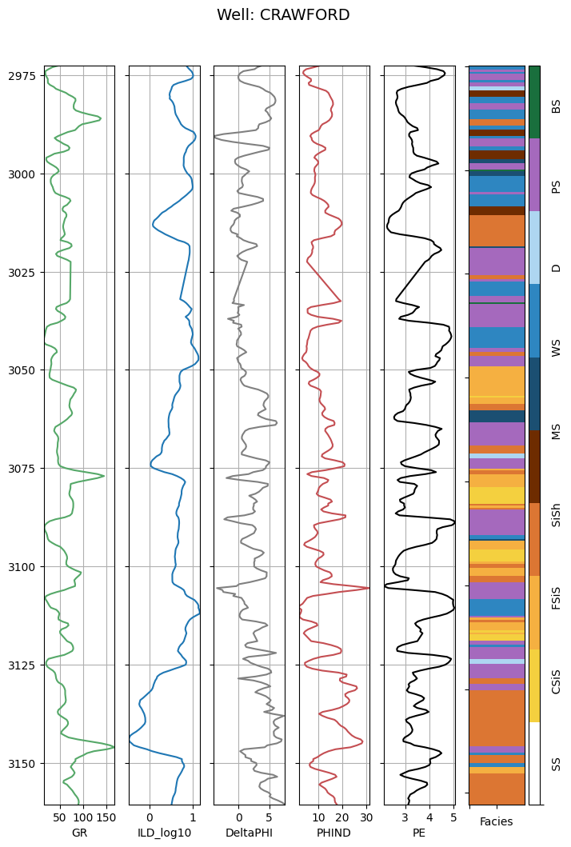

Finally we can write out a csv file with the well data along with the facies classification results.

In [82]:

well_data.to_csv('well_data_with_facies.csv')

## References¶

Amato del Monte, A., 2015. Seismic Petrophysics: Part 1, *The Leading Edge*, 34 (4). [doi:10.1190/tle34040440.1](http://dx.doi.org/10.1190/tle34040440.1)

Bohling, G. C., and M. K. Dubois, 2003. An Integrated Application of Neural Network and Markov Chain Techniques to Prediction of Lithofacies from Well Logs, *KGS Open-File Report* 2003-50, 6 pp. [pdf](http://www.kgs.ku.edu/PRS/publication/2003/ofr2003-50.pdf)

Dubois, M. K., G. C. Bohling, and S. Chakrabarti, 2007, Comparison of four approaches to a rock facies classification problem, *Computers & Geosciences*, 33 (5), 599-617 pp. [doi:10.1016/j.cageo.2006.08.011](http://dx.doi.org/10.1016/j.cageo.2006.08.011)